Assignment-operating system information,windows,linux,macOS installation and adjust os setting
--
1. On your Windows laptop or PC, open 'System Information' and take a screenshot showing your OS version, processor, and RAM details.
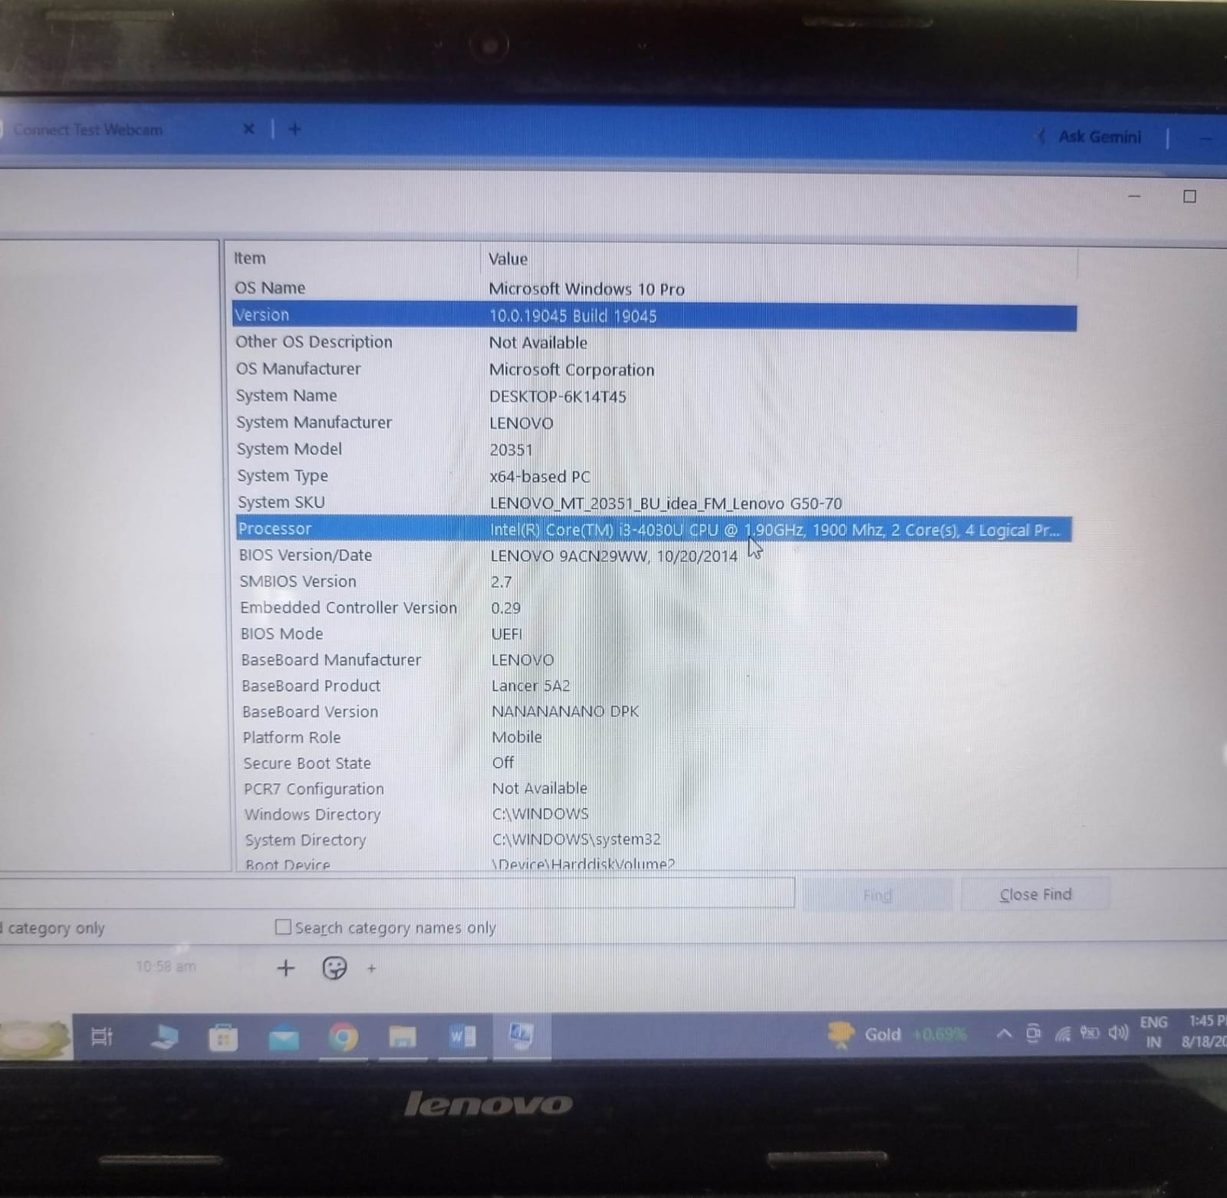
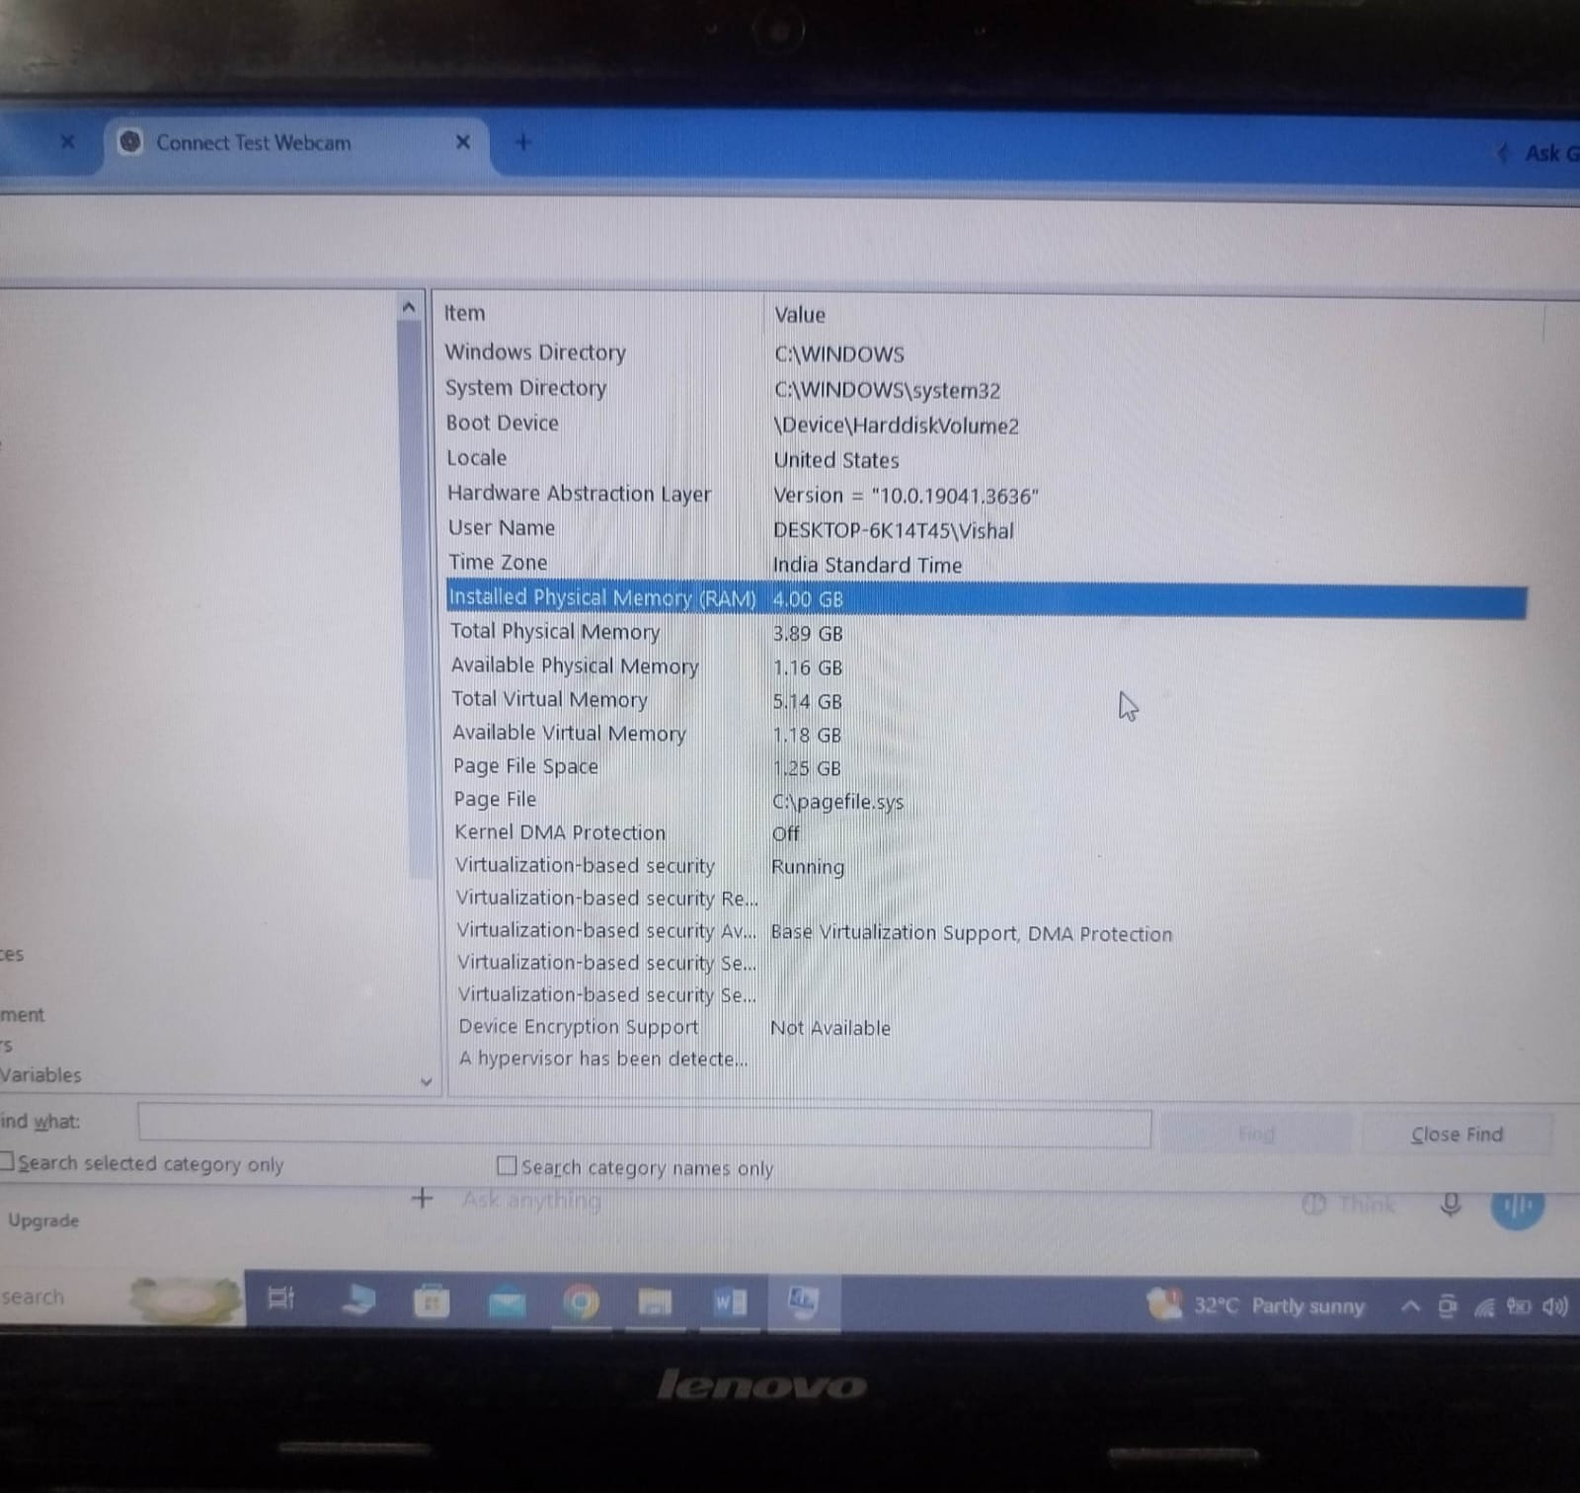

2. Download any official Linux distribution ISO (like Ubuntu or Fedora), and use Rufus or BalenaEtcher to create a bootable USB drive for installation.<br><br><em><strong>Hint:</strong> If you don't have a spare USB, use a virtual machine tool like VirtualBox to mount the ISO and start the installation process virtually.</em>
-----
Steps: Install Ubuntu Linux in VirtualBox
1.Download Ubuntu ISO
Go to the official Ubuntu website: Ubuntu Downloads
Download the Ubuntu Desktop LTS ISO.
The file will look similar to ubuntu-24.04.x-desktop-amd64.iso.
2.Install VirtualBox
Download VirtualBox from Oracle VirtualBox
Install it on your Windows computer.
3.Create a virtual machine
Open VirtualBox.
Click New.
Name: Ubuntu Linux
Type: Linux
Version: Ubuntu (64-bit)
Give it around 4 GB RAM if your PC can handle it.
Create a virtual hard disk of around 25 GB or more.
4.Mount the ISO
Select your Ubuntu virtual machine.
Click Settings → Storage.
Select the empty optical drive.
Choose Add/Choose a disk file.
Select the downloaded Ubuntu .iso file.
5.Start the virtual machine
Click Start.
VirtualBox will boot from the Ubuntu ISO.
6.Start Ubuntu installation
Ubuntu's installer will appear.
Select your language.
Choose Install Ubuntu.
Follow the installation instructions.
Create your username and password.
7.Finish
After installation, restart the virtual machine.
Ubuntu should now start from the virtual hard disk.
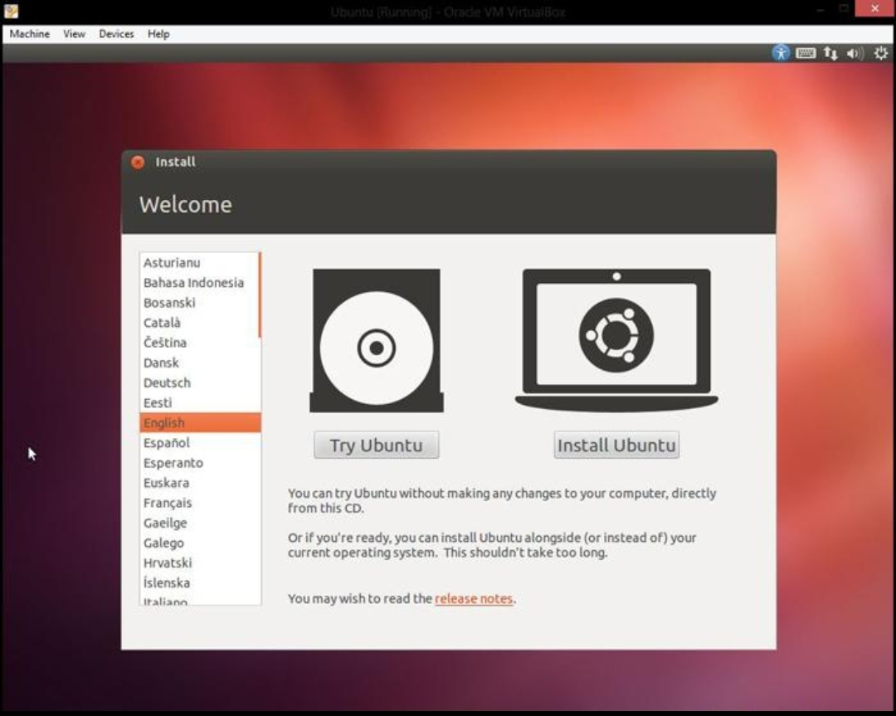
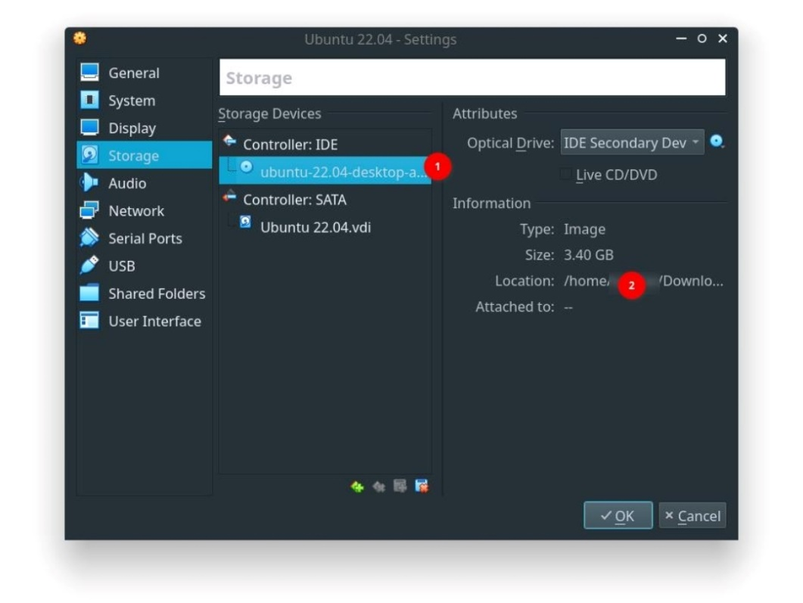
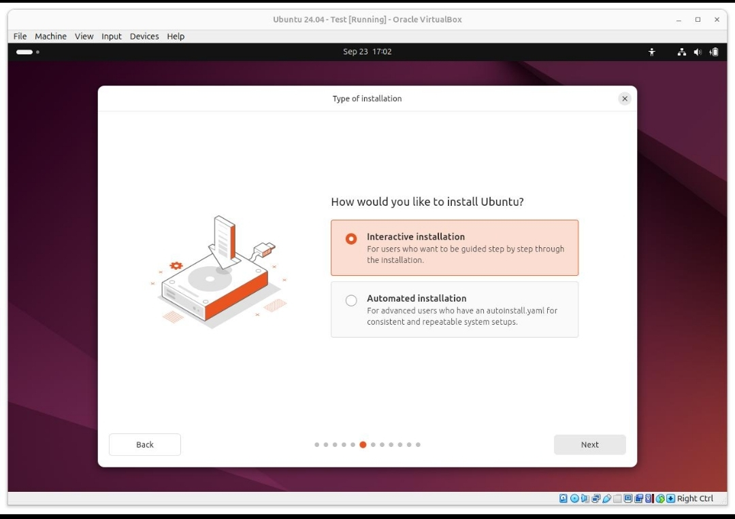
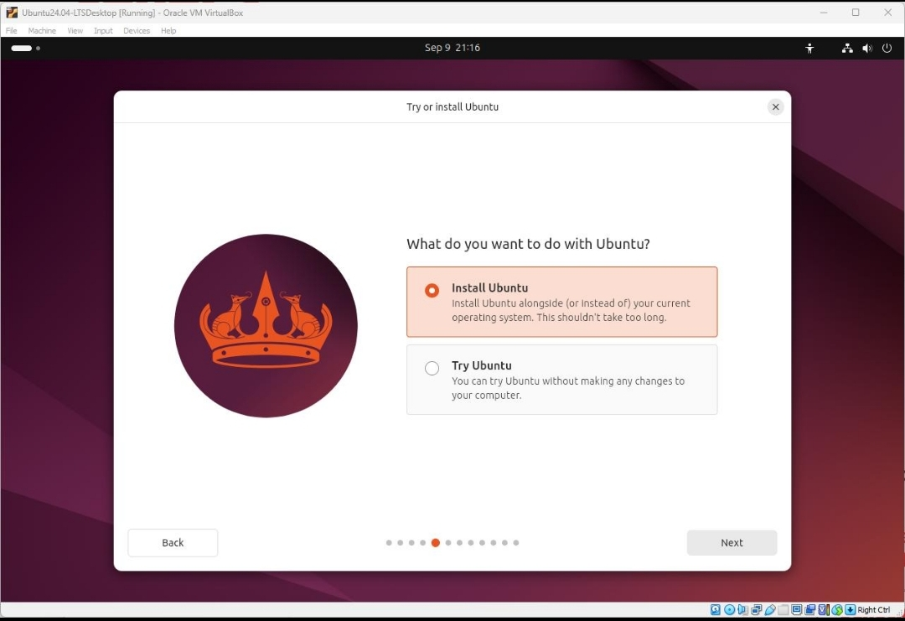
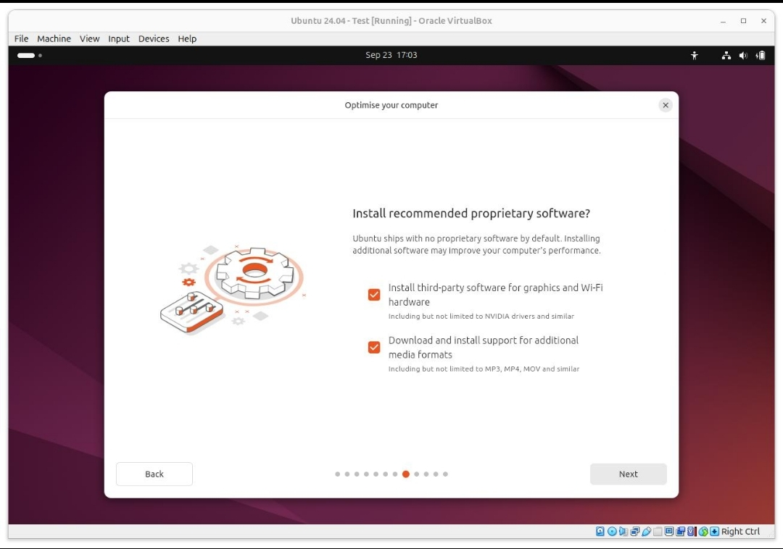
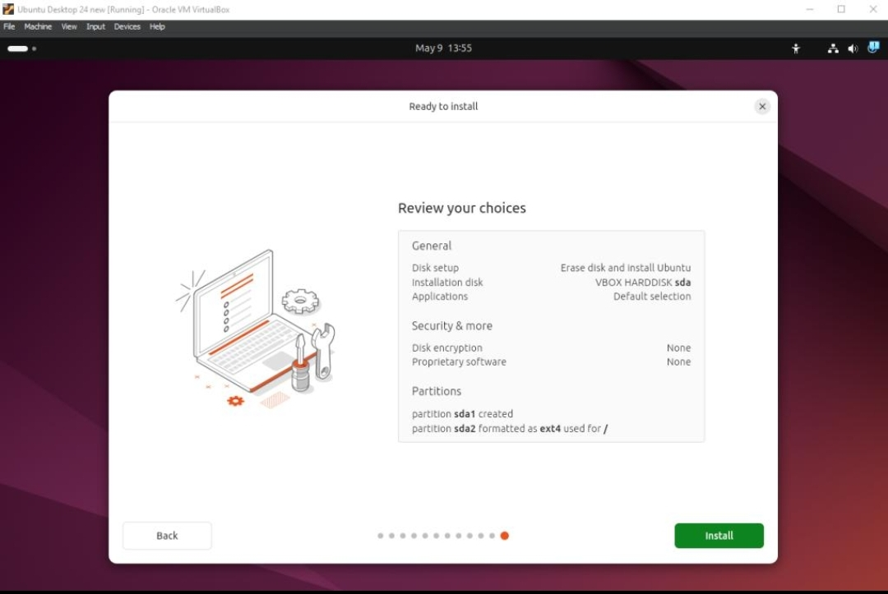

3.On a macOS device (or using a macOS virtual machine), open 'System Preferences' and change the desktop wallpaper, then adjust the system language to Hindi or Gujarati.<br><br><em><strong>Hint:</strong> Find 'Language & Region' in System Preferences to add or change languages.</em>
------
1. Change the desktop wallpaper
Click Apple → System Settings.
Select Wallpaper.
Choose any wallpaper.
2. Change the system language to Hindi or Gujarati
Open Apple → System Settings.
Go to General → Language & Region.
Click + under Preferred Languages.
Add Hindi or Gujarati.
Move it to the top of the list if you want it to be the main system language.
Follow the restart/log-out prompt.

4.Install a fresh copy of Ubuntu Linux (real or virtual machine) and create a new user account named 'gamer'. After installation, enable automatic login for this user and take a screenshot of the login screen showing the username.
------

1. Install Ubuntu in VirtualBox
- Open VirtualBox.
- Click New.
- Name the VM: Ubuntu
- Select the downloaded Ubuntu ISO.
- Give it at least:
  - RAM: 4 GB
  - CPU: 2 cores
  - Disk: 25 GB
- Start the VM.
- Select Install Ubuntu.
- Follow the installation wizard.

2. Create the user gamer
During Ubuntu installation, you will reach Who are you?
Enter:
- Your name: Gamer
- Computer name: ubuntu
- Username: gamer
- Password: choose a password
Then continue the installation.
After installation, Ubuntu will automatically create the gamer account.

3. Enable automatic login
After Ubuntu starts:
- Open Settings.
- Select System → Users.
- Click Unlock.
- Enter your password.
- Select the gamer account.
- Find Automatic Login.
- Turn Automatic Login → ON.
- Restart Ubuntu.
Ubuntu should now automatically enter the gamer account without asking for the password.

4. Show gamer on the login screen
Because automatic login skips the login screen, you can temporarily get back to the login screen by:
Ubuntu menu → Log Out
The Ubuntu login screen should show the gamer account.

5.Use ChatGPT to generate a step-by-step guide for installing Windows 10 on a laptop, including partitioning tips and post-installation settings for privacy and updates. Follow the guide and note any steps that were unclear or missing.
------

1. Prepare the Windows 10 installer
- Download an official Windows 10 ISO from Microsoft.
- Create a bootable USB using Rufus or another trusted tool.
- Plug the USB into the laptop.
- Restart the laptop and open the Boot Menu (the key varies by manufacturer, commonly F12, F9, Esc, or another key).
- Select the USB drive.

2. Start Windows installation
- Select:
  - Language
  - Time and currency format
  - Keyboard
- Click Next → Install now.
- Enter your product key if you have one.
  - If you have a valid digital license, you can select I don't have a product key and activate later.
- Select the correct Windows 10 edition that matches your license.
- Accept the license terms.
- Select Custom: Install Windows only (advanced).

3. Partitioning tips
You'll see the laptop's disks and partitions.
If you want a completely fresh installation:
- Identify the correct internal drive carefully.
- Delete the old Windows partitions only after confirming your important data is backed up.
- Select the resulting Unallocated Space.
- Click New and allow Windows Setup to create the required system partitions.
- Select the main/new partition and click Next.
If you want to keep an existing data partition:
- Do not delete or format it.
- Select only the partition intended for Windows.

4. Complete installation
Windows will copy files and restart several times.
When prompted:
- Select your region.
- Select your keyboard layout.
- Connect to Wi-Fi/Ethernet if required.
- Sign in with a Microsoft account or choose an available offline/local-account option.
- Create your password/PIN.
- Complete the Windows setup.

5. Install drivers
After reaching the desktop:
- Open Settings → Update & Security → Windows Update.
- Click Check for updates.
- Install available updates.
- Restart when requested.
- Check Device Manager for devices with missing drivers.
- If necessary, download drivers from your laptop manufacturer's official support website.

6. Privacy settings
Go to:
Settings → Privacy
Review settings such as:
- Location
- Camera
- Microphone
- Account info
- Contacts
- Diagnostics & feedback
- Activity history
Turn off permissions you don't need.

7. Update and security settings
Go to:
Settings → Update & Security → Windows Update
Then:
- Install available security updates.
- Enable automatic updates.
- Check Windows Security.
- Make sure Microsoft Defender Antivirus is enabled.
- Check Firewall & network protection.

8. Final checks
Open Device Manager and verify that there are no devices showing a yellow warning symbol.
Also test:
- Wi-Fi
- Bluetooth
- Sound
- Webcam
- Keyboard/touchpad
- USB ports
- Display/brightness
- Sleep/restart/shutdown

